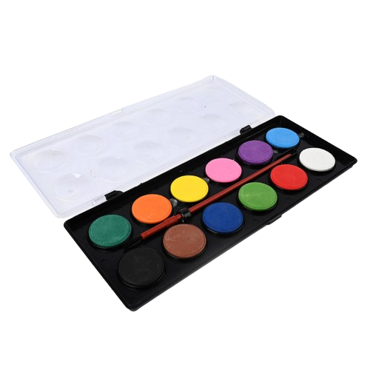

**Product details**

**Water Colors**

**Price: $4.99**

**Paint Your Imagination, Fluid and Free.**

**Water Color paints offer vibrant, transparent hues that bring your artwork to life. Perfect for beginners and professionals alike, these paints are easy to blend, providing smooth coverage and stunning washes. Whether you're working on landscapes, portraits, or abstract art, Water Color paints help you create beautifully fluid masterpieces.**

**.**

.

**THANK YOU!**

**WELLCOME TO OUR WEBSITE**